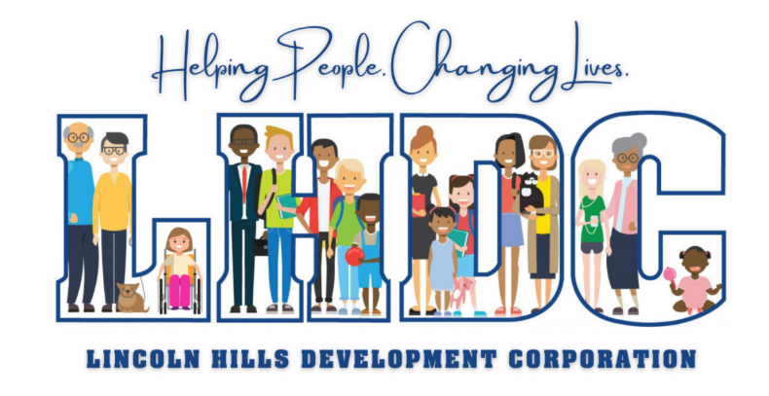

Head Start Birth-5 2020-2021 Annual Report
Financial Audit Review
Non-Federal Share funds include, but are not limited to, parent volunteers in the home or at preschool and program governance that includes serving on the Head Start Birth-5 Policy Council.
The most recent financial audit determined LHDC to be a “low-risk auditee” with no questioned or disallowed audit costs.
Financial and Budget Review
2020-2021 Fiscal Year
Continuation Base Grant COVID-19 Relief Funding

Office of Head Start Grant Award $4,033,039 CARES Act $326,038
Non-Federal Share $1,008,259 CRRSA Funds $111,660
COLA/QI Supplement $186,326 ARP Funds $443,902
Total Operating Budget $5,227,624 Total Additional Funding $881,562

Head Start funds are utilized for program operations, facility maintenance, and to provide Head Start and Early Head Start services to children and families in LHDC's four county service area including Crawford, Harrison, Perry, and Spencer Counties.

COVID-19 Pandemic
Due to the ongoing challenges of COVID-19, the Office of Head Start allowed flexibility during the 2020-2021 program year. This flexibility allowed us to operate the program to meet the needs of the community during this challenging time. LHDC Head Start Birth-5 implemented a COVID-19 Procedures Manual to guide staff through providing comprehensive services during a pandemic while implementing measures to prevent and respond to COVID-19.
LHDC Head Start Birth-5 provided services during the 2020-2021 program year utilizing a locally designed option due to COVID-19, ensuring social distancing in classrooms and while transporting children to and from school. Services included both in-person and virtual learning. Children enrolled in virtual learning were delivered meals and educational learning packets while families were engaged through Zoom meetings, phone calls, and other virtual platforms.
LHDC Head Start Birth-5 took measures to prevent the spread of COVID-19 through daily health screenings, mask wearing, and additional sanitizing protocols.

Enrollment
LHDC Head Start Birth-5 funded enrollment is 371, which includes 273 Center-Based Head Start, 18 Home-Based Head Start, and 80 Home-Based Early Head Start. During the 2020-2021 program year, the Office of Head Start allowed program flexibility to create a locally designed option to prepare for, prevent, and respond to COVID-19. Such flexibility included offering smaller classroom sizes to ensure social distancing, so children were enrolled in both center-based learning and virtual learning options.
Selection criteria is based on community needs including family income, homelessness, whether the child is in foster care, the child’s age, whether the child is eligible for special education services and other family or child risk factors.

A Healthy Child is a School Ready Child
LHDC Head Start Birth-5 is committed to supporting families and children by providing health care and insurance resources, health reminders, guest speakers, and educational handouts to ensure all families understand the importance of preventative care and well child exams. Staff assist families in acquiring medical and dental homes as well as providing referrals to LHDC’s Health Care Navigators for help with obtaining health insurance. During the 2020-2021 program year, LHDC Head Start Birth-5 provided COVID-19 information to families on the importance of washing hands and wearing masks to prevent, reduce and respond to COVID-19. COVID-19 impacted families and their ability to complete EPSDT Medical Exams, Immunizations and Preventative Dental Care.

Preparing Children for School
LHDC Head Start Birth-5 School Readiness Goals articulate the program’s expectation of a child’s status and progress across the five essential domains of child development and early learning that will improve school readiness for preschool and kindergarten. The five essential domains are Language and Literacy, Cognitive and General Knowledge, Approaches to Learning, Social Emotional, and Physical Well-Being and Motor Development. Goals are developed around the Head Start Early Learning Outcomes Framework, Indiana Learning Foundations, Preschool and Kindergarten School Readiness Goals, and parent goals. To improve school readiness goals, child assessment data is aggregated and analyzed.

Summer Learning Program
LHDC Head Start Birth-5 operated a five-week summer learning program at North Crawford, South Crawford, South Spencer, and South Perry Head Start Centers. Seventy-nine (79) children participated. This summer learning program was designed to help bridge the learning gap due to the COVID-19 pandemic. Highest priority was provided to children who were transitioning to kindergarten and were identified with developmental concerns.
Parent Involvement
LHDC Head Start Birth-5 advocates and supports parents in being their child’s most important teacher. Head Start Birth-5 promotes shared responsibility with parents for their child’s early learning and development. Through a “Family Partnership Agreement,” staff and families identify strengths in the following areas: Family Well-Being, Positive Parent-Child Relationships, Families as Lifelong Educators, Families as Learners, Family Engagement in Transitions, Family Connections to Peers and Community, and Families as Advocates and Leaders. Head Start Birth-5 works to instill confidence and success in both children and families in school and everyday life by developing goals, individualizing services, and providing resources as well as support and encouragement. There is a great deal of evidence that indicates fathers play an important role in healthy child development and can lead to better child outcomes in a number of areas. During the 2020-2021 program year, 85 fathers volunteered across LHDC’s Head Start Birth-5 four-county service area.

